Bethel Summerfest Parade
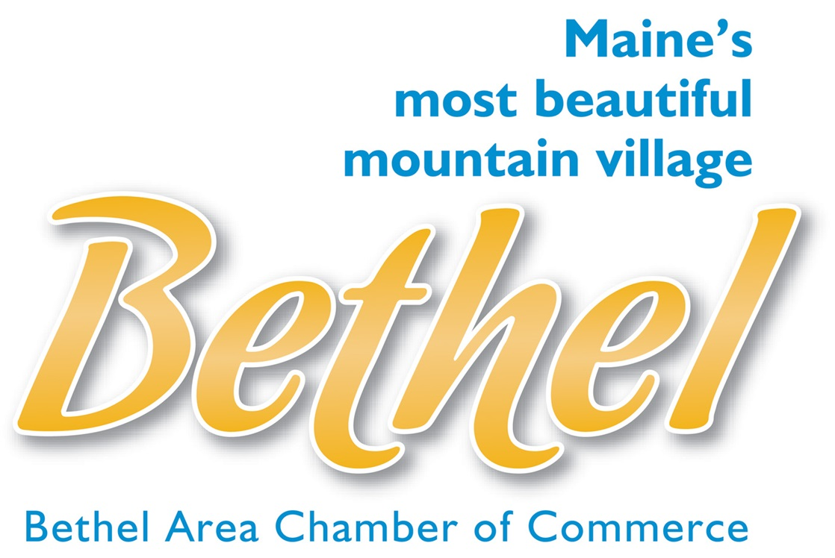
11:00 am - Saturday, July 15, 2023
Theme: “Mahoosuc Adventures”

Do you have a band, a cool car, truck, or tractor, ATV’s, horses or other furry friends, some awesome dance moves, or are you in a club that has a creative idea for a float? Want to dress up your bikes, pets, family, friends, or coworkers in fun costumes together? Then we want YOU!

Participants may choose to create a float or march as a group to represent the theme, "Mahoosuc Adventures," showing off your favorite ways to have fun in our mountain communities. Of course, you are also welcome to march or drive anything that shows off representation of your business, organization/club/team/class, or family. All entries will be judged for the chance to win prize money!

PARADE ORGANIZERS RESERVE THE RIGHT TO REFUSE ENTRY FOR ANY REASON. The parade is meant to be a fun celebration. Please avoid controversial material.

Parade line-up begins at 10:00am in the River Lanes parking lot on Cross Street. Parade starts at 11:00am. Winners will be announced at the gazebo on the common as soon as possible after the parade. Please have at least one member of your group there in case your float wins an award.

Pre-registration is preferred, but you may fill out the paperwork at parade line-up.

The rules:
- Participants must return this registration form and a liability waiver signed by everyone accompanying the float to the Bethel Area Chamber of Commerce at the address listed on the application. Pre-registration is preferred but applications will be accepted on the day of the parade.
- Parade line-up begins at 10:00am in River Lanes parking lot on Cross Street. Parade starts at 11:00am.
- To submit an entry to be judged, please submit a brief written explanation of how the float illustrates the theme below. Prizes will be awarded to the top three floats/entries.
- Winners will be announced at the gazebo on the common at approximately 11:45pm or ASAP after the parade is complete. Please have at least one member of your group there in case your float wins an award.
- BE SAFE!

- NO SIRENS or HORNS.
- DO NOT LET CHILDREN SIT ON THE EDGE OF YOUR MOTORIZED FLOAT.
- BE AWARE OF CHILDREN RUNNING OUT TO RETRIEVE CANDY ALONG THE ROUTE.

Return this form and attached waivers to: Bethel Area Chamber of Commerce
P.O. Box 1247
Bethel, ME 04217
(You may scan and email it to connect@bethelmaine.com)

ORGANIZATION/BUSINESS: _______________________________________________________________

CONTACT PERSON: _____________________________________________________________________

ADDRESS: ___________________________________TOWN:__________________STATE:____ZIP:_____

E-MAIL:_________________________________________________________________________________

CELL PHONE: ______________________________________(Contact must be reachable during the parade)

Describe your parade entry:__________________________________________________________________

Please fill out box below if you would like to enter to be judged for awards. Use extra paper if necessary.

Name of entry: ____________________________________________________________________
How does your entry represent your business, school, family, etc.? Describe your entry.

Bethel Summerfest Parade 2023 LIABILITY WAIVER
(Including General Release and Covenant-Not-to-Sue)

Please read this entire document. Insert the name of your organization as indicated. Instruct each person associated with your parade entry (parent or guardian, for a minor) to complete and sign in the appropriate spaces at the bottom. Return the signed and completed form(s) with the Parade Participation Form.

IN CONSIDERATION of being granted a position as an entrant and/or permission to participate in the Bethel Summerfest Parade by the Bethel Area Chamber of Commerce, (the “Parade”), or on behalf of a minor child, the undersigned agrees and states as follows:

1. The undersigned is aware of and understands the inherent risks, hazards and dangers associated with parade participation (which are printed below and incorporated herein as though appearing above the signature of the undersigned) and, notwithstanding that the actual conditions at the Parade may pose more or less risks, hazards and dangers than those so enumerated, the undersigned nevertheless elects, voluntarily, to enter and/or participate in the Parade on the terms, conditions, and covenants set forth herein. In this regard, the undersigned, for himself/herself/itself and for his/her heirs, successors, assignees, personal representatives, and next of kin, hereby releases, waives, discharges, covenants not to sue and agrees to hold harmless the Bethel Area Chamber of Commerce and each of them, as well as its officers, directors, agents, sponsors, volunteers, and employees; from all liability for any and all causes and claims of every type and nature whatsoever, including but not limited to property damage, injury to person and/or death, or otherwise, without limitation, arising out of or alleged to be arising out of the conduct of the Parade, the pre-Parade formation, staging, placement, judging, organizational meetings, post-Parade ceremonies, and any other Parade event sanctioned by the Bethel Area Chamber of Commerce.

2. The undersigned hereby promises that the state of his or her physical health will, on the day of the Parade, be sufficiently sound to permit such person to safely participate. If such person will be handling any animal, motorized vehicle, apparatus, device, firearm, or other thing in the Parade, he/she is possessed of sufficient experience in doing so that the life, limb, or property of self and others will not be exposed to unreasonable risk of harm.

3. I also understand that any PHOTOS taken of me or my family members at this public event may be used for Chamber purposes, including, but not limited to: websites, print brochures, or newspaper advertising.

4. THE UNDERSIGNED HAS READ AND UNDERSTANDS THIS RELEASE AND COVENANT-NOT-TO-SUE IN ITS ENTIRETY AND VOLUNTARILY SIGNS SAME, without reliance on any representations, statements, or inducements, express or implied, made by any party whomsoever.

RISKS, HAZARDS, AND DANGERS ASSOCIATED WITH PARADE PARTICIPATION
Parades involve inherent risks, hazards, and conditions that may be dangerous to life, limb, and property and that can arise in an incalculable variety of unforeseeable or foreseeable ways which may include (as examples, but not necessarily as a complete list) the following: The presence and use of horse and other animals, motor vehicles, machinery, firearms, floats, fireworks, acrobats, projectiles, aerial demonstrations, baton twirling, wind, rain, hail, and other forces of the elements, and other threats to life and limb, such as the possibility of slipping and falling and complications associated with weather conditions and physical exertion (such as heat stroke, fainting, collapse, exhaustion, or other more serious complications).

Continued…

Individual/Organization/Business: _____________________________________________

EVERY PERSON IN THE PARADE MUST SIGN BELOW:
DATE | SIGNATURE  By my signature, I acknowledge that I have read and understand the Liability Waiver. (Parent or legal guardian must sign for a minor) | PRINT NAME | NAME OF MINOR  (if applicable)
Please return this liability waiver and parade registration form to:

Bethel Area Chamber of Commerce
P.O. Box 1247, 8 Station Place
Bethel, ME 04217
Tel. 207-824-2282 ~ Fax: 207-824-7123
Or scan and email: connect@bethelmaine.com
